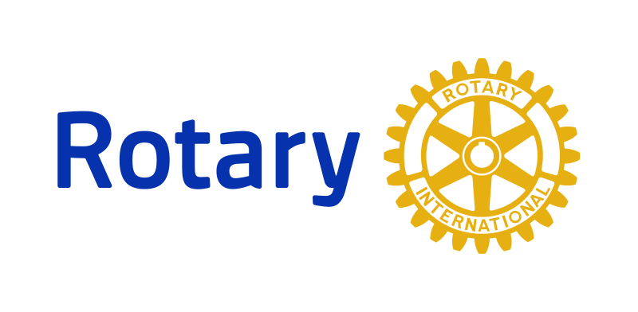**Fireside Chat**

**What Rotary is:**

1. It is an organization of business and professional people pledged to uphold the highest of personal and professional standards

2. It is a service club. In fact it is the oldest service club in the United States.

3. It Is international. There are Rotary Clubs worldwide.

4. It is a club whose members recognize and exemplify the charity and sacrifices that one should expect from those who believe they have a responsibility to help others.

5. It is Service Above Self.

**What Rotary is not:**

1. It is not a religious organization, though Rotarians believe in a higher power.

2. It is not a political organization, but Rotarians are good citizens.

**The Four-Way Test**

These bring a surprising clarity to all business and personal interactions.

Of the things we think, say and do:

1. Is it the TRUTH

2. Is It FAIR to all concerned

3. Will it bring GOOD WILL and BETTER FRIENDSHIPS

4. Will it be BENEFICIAL to all concerned

**Rotary Organization**

1. 1.2 Million members worldwide

2. 35,000 Clubs in 206 Countries and geographical areas around the world

3. Our club is in District 6690

**Rotary International Information:** Information is available on the International website at https://www.rotary.org There is a lot of information on the site and you are encouraged to browse it at your leisure.

**Rotary District Information:** Our district web site can be found at http://rotary6690.org Here you will be able to find information regarding the district, its activities and officers. There are approximately 530 districts in Rotary organized into 34 zones.

**Rotary Club Information:** The club web site is found at WEBSITE ADDRESS and provides links to the above sites. Information about the club and current activities is available.

**The Rotary Foundation**

The Rotary Foundation is a not-for-profit corporation that supports the efforts of Rotary International to achieve world understanding and peace through international humanitarian, educational and cultural exchange programs. It is supported solely by voluntary contributions from Rotarians and friends of the Foundation who share its vision of a better world.

The Foundation was created in 1917 by Rotary International’s sixth president Arch C. Klumph, as an endowment fund for Rotary “to do good in the world.” It has grown from an initial contribution of US$26.50 to more than US $130 million. Its event-filled history is a Story of Rotarians learning the value of service to humanity. The Foundation's Humanitarian Programs fund international Rotary club and district projects to improve the quality of life, providing health care, clean water, food, education, and other essential needs primarily in the developing world. One of the major Humanitarian Programs is Polio-Plus, which seeks to eradicate the polio virus worldwide. Through its Educational Programs, the Foundation provides funding for some 1,200 students to study abroad each year. Grants are also awarded to university teachers to teach in developing countries and for exchanges of business and professional people. Former participants In the Foundation's programs have the opportunity to continue their affiliation with Rotary as Foundation Alumni. Projects and programs funded by the foundation typically involve a partnership between multiple clubs and districts in at least two countries.

Through the SHARE system, contributions to The Rotary Foundation are transformed into grants that fund local and international humanitarian projects, scholarships, and activities, such as vocational training teams. At the end of every Rotary year, contributions directed to the Annual Fund-SHARE from all Rotary clubs in the district are divided between the World Fund and the District Designated Fund, or DDF. At the end of three years, your district can use the DDF to pay for Foundation, club, and district projects that your club and others in the district choose. Districts may use up to half of their DDF to fund district grants. The remaining DDF may be used for global grants or donated to PolioPlus, the Rotary Peace Centers, or another district.

**Paul Harris Fellowship**

A Paul Harris Fellow recognition is given to a member who has contributed in their name a total of $1,000.00 to the Rotary Foundation. The honor is named after Mr. Paul Harris, an attorney, who started Rotary in 1905 in Chicago. All Rotarians are encouraged, but not required to become PHF's. Rotarians are asked to become Sustaining Members by pledging and giving $100 per year to the Rotary Foundation. Our club makes this contribution through our dues and each member is a sustaining member.

**The Strategic Plan**

Rotary’s strategic plan provides the framework for our future, ensuring that we continue to be known as a respected, dynamic organization that advances communities worldwide. The strategic plan evolves with the aspirations of Rotarians. It is shaped by regular input from members through surveys, focus groups, committees, and meetings, so it can continue to help us achieve our goals. Read more at https://www.rotary.org/myrotary/en/learningreference/about-rotary/strategic-plan

**Rotary Areas of Focus**

- Fighting Disease

- Growing Local Economies

- Promoting Peace

- Providing Clean Water

- Saving Mothers and Children

- Supporting Education

- The Environment

**Rotary also works on…**

- Building Community

- Developing Leaders

- Disaster Recovery

- Empowering Youth

- Eradicating Polio

- Convention